**Airline Review Classification Using Machine Learning**

1. **INTRODUCTION :**

**1.1) PROJECT OVERVIEW :**

Objective: To develop a machine learning model to classify airline reviews into positive, negative, or neutral sentiment.

Motivation: Airline reviews are a valuable source of feedback for airlines. By understanding the sentiment of airline reviews, airlines can identify areas where they need to improve their services. This can lead to improved customer satisfaction and loyalty.

Approach: The project will use a machine learning algorithm to train a model on a dataset of airline reviews. The model will be trained to identify the sentiment of each review and to classify it as positive, negative, or neutral.

**1.2) PURPOSE :**

* Identify areas where they need to improve their services. For example, if airlines see that many customers are complaining about flight delays, they can take steps to reduce delays, such as improving their scheduling and maintenance procedures.
* Personalize the customer experience. Airlines can use the sentiment of airline reviews to personalize the customer experience. For example, they can recommend flights or products to customers based on their past travel history and preferences.
* Improve marketing campaigns. Airlines can use the sentiment of airline reviews to improve their marketing campaigns. For example, they can focus on promoting the positive aspects of their services and addressing the negative aspects.
* Identify customer segments. Airlines can use the sentiment of airline reviews to identify different customer segments. This information can then be used to target marketing campaigns and improve customer service.

Overall, the purpose of this project is to help airlines to improve their services and customer satisfaction by developing a machine learning model to classify airline reviews into positive, negative, or neutral sentiment.

1. **LITERATURE SURVEY :**

**2.1) Existing Problem :**

One existing problem for the project "Airline Review Classification Using Machine Learning" is the lack of a large, high-quality dataset of airline reviews. This is because airline reviews are often difficult to collect and label. Airlines are typically reluctant to release their own customer data, and it can be time-consuming and expensive to manually label airline reviews.

Another existing problem for this project is the potential for bias in the machine learning model. This is because the model will be trained on a dataset of airline reviews, which may be biased towards certain groups of people or certain types of reviews. For example, if the dataset contains more reviews from male business travelers than from female leisure travelers, the model may be biased towards male business travelers.

**2.2) References :**

* <https://www.kaggle.com/datasets/juhibhojani/airline-reviews>
* <https://www.ibm.com/topics/machine-learning>
* <https://smartinternz.com/saas-guided-project/444/airline-review-classification-using-machine-learning>

**2.3) Problem Statement Definition :**

Our project aims to develop an automated system that classifies airline reviews for sentiment analysis, helping airlines improve customer satisfaction and operational performance by efficiently categorizing and responding to customer feedback from various online platforms.

1. **IDEATION & PROPOSED SOLUTION**

**3.1) Empathy Map Canvas :**

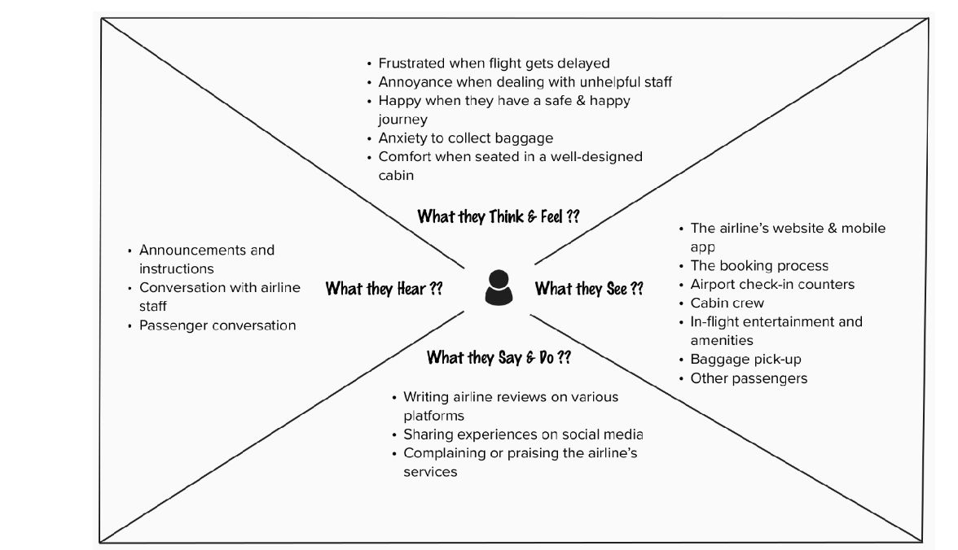

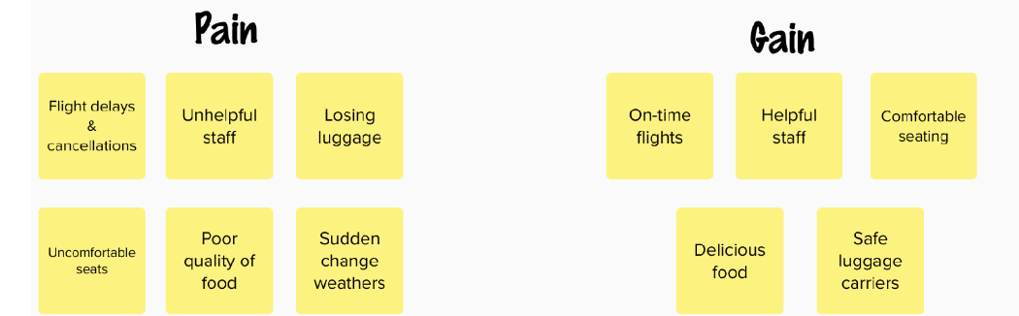

**3.2) Ideation & Brainstorming :**

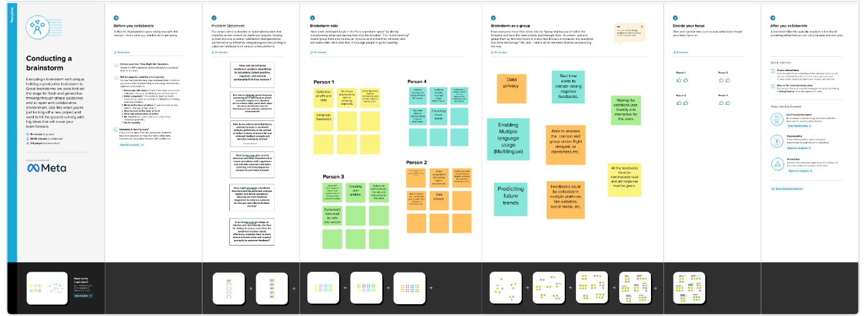

1. **REQUIREMENT ANALYSIS :**

**4.1) Functional requirement :**

The functional requirements for the project "Airline Review Classification Using Machine Learning" are as follows:

FR1: The system shall be able to accurately classify airline reviews into positive, negative, or neutral sentiment.

FR2: The system shall be able to handle airline reviews of different lengths and complexity.

FR3: The system shall be able to handle airline reviews in multiple languages.

FR4: The system shall be able to provide users with explanations of the model's predictions.

FR5: The system shall be able to be deployed as a web application so that users can submit airline reviews and receive predictions of their sentiment.

**4.2) Non-Functional requirements :**

* Performance: The system should be able to classify airline reviews in real time.
* Scalability: The system should be able to handle a large number of airline reviews without sacrificing performance.
* Availability: The system should be available 24/7/365.
* Reliability: The system should produce accurate and consistent predictions.
* Security: The system should protect user data from unauthorized access and modification.
* Usability: The system should be easy to use for both airlines and customers

**5. PROJECT DESIGN :**

**5.1) Data Flow Diagrams and User stories:**

**Level 0 DFD (Context Diagram):**

The Level 0 diagram provides an overview of the system and its interactions with external entities.

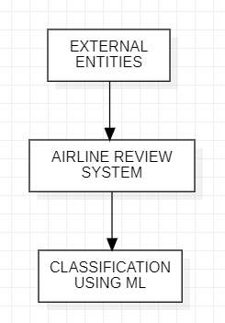

**Level 1 DFD:**

The level 1 DFD illustrates the major processes and data flows within the system.

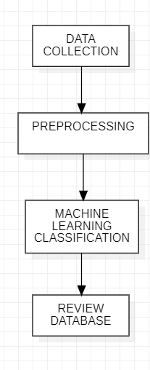

**Level 2 DFD:**

Creating a Level 2 DFD requires breaking down the processes from the Level 1 DFD into more detailed subprocesses.

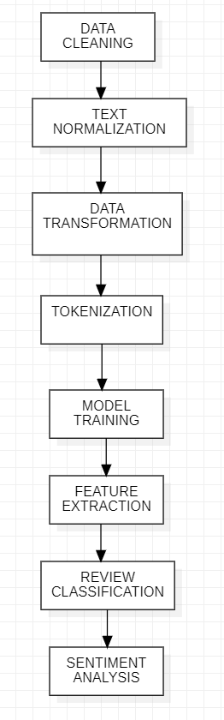

**5.2) Solution Architecture:**

Solution architecture is a complex process- with many sub-processes- that bridges the gap between business problems and technology solutions. Its goals are to:

· Find the best tech solution to solve existing business problems.

· Describe the structure, characteristics, behaviors, and other aspects of the software to project stakeholders.

· Define features, development phases, and solution requirements.

· Provide specifications according to which the solution is defined, managed, and delivered.

**EXAMPLE-SOLUTION ARCHITECTURE DIAGRAM:**

We have designed a solution architecture diagram for an automated system that classifies airline reviews for sentiment analysis involving various components.

Given below is an outline of a potential architecture for this project:

|  |  |
| --- | --- |
|  |  |

**1.**  **DATA COLLECTION**

**2.** **DATA PRE-PROCESSING**

**3.** **DATA STORAGE**

**4.** **SENTIMENT ANALYSIS**

**5.** **FEEDBACK CATEGORIZATION**

**6.** **USER AUTHENTICATION**

**7.** **WEB INTERFACE**

**8.** **APIs**

**9.** **REPORTING AND INSIGHTS**

**10.** **NOTIFICATION SYSTEM**

**11.** **SCALABILITY**

**12.** **SECURITY**

**13.** **CONTINUOUS TRAINING AND IMPROVEMENT**

**14.** **DATA BACKUP AND RECOVERY**

**15.** **MONITORING AND ALERTS**

**16.** **COMPLIANCE**

**17.** **INTEGRATION**

**18.** **TESTING AND QUALITY ASSURANCE**

**19.** **DOCUMENTATION**

**20.** **MAINTENANCE AND SUPPORT**

**6. PROJECT PLANNING AND SCHEDULING :**

**6.1) Technical Architecture:**

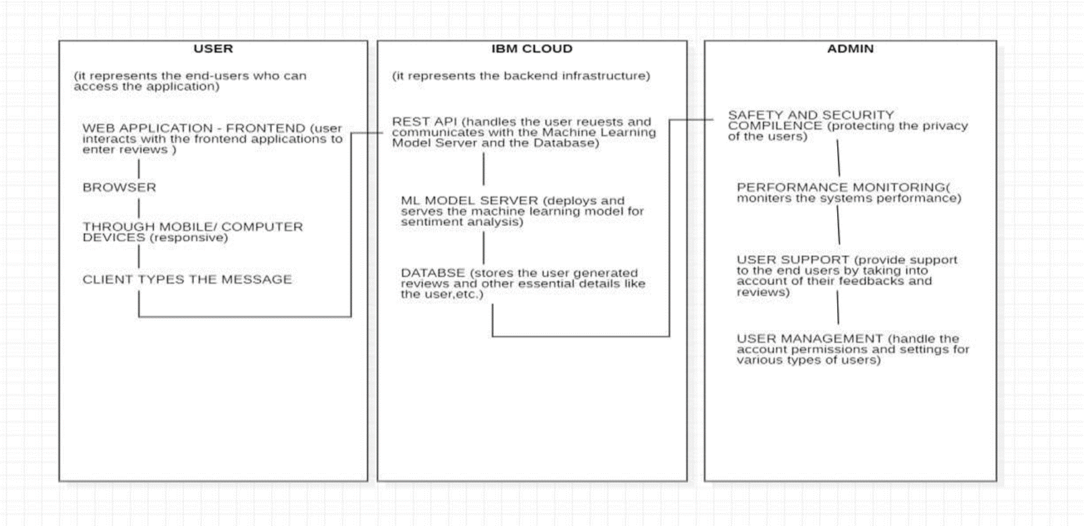**USER :**

· This column represents end-users accessing your application through web browsers or mobile apps.

· Users interact with the frontend application to input airline reviews and receive sentiment analysis results.

## IBM CLOUD:

· REST API: This component handles user requests and communicates with the Machine Learning Model Server and the Database.

· ML Model Server: This part is responsible for deploying and serving the machine learning model used for sentiment analysis.

· Database: It stores user-generated data, such as reviews, and any relevant metadata or admin configurations.

## 

## 

## ADMIN:

· Security and Compliance: The Admin component is responsible for ensuring data security and compliance with privacy regulations. Admins implement and manage security measures, such as access controls, encryption, and auditing.

· Review Monitoring: Admins can access and review the data collected from users' airline reviews. They can analyze trends and identify potential issues or areas for improvement based on the sentiment analysis results.

· User Support: Admins can provide support to end-users by assisting with issues, questions, or feedback related to the application. They may also use the Admin interface to respond to user inquiries.

· User Management: Admins can create, modify, and manage user accounts, including user roles and access levels. They can also handle account permissions and settings for different types of users, such as regular users and other administrators.

**6.2) Sprint Planning and Estimation:**

Sprint planning and estimation typically follows an agile methodology, such as Scrum. The following methods were taken into account for the successful completion of the project.

**Product Backlog:**

We started the project by creating a product backlog, which is a prioritized list of features, user stories, and tasks for our project. These items include various fields such as,data collection, preprocessing, model training, database setup, and more. The product backlog was maintained and updated throughout the project.

**Sprint Planning:**

Sprint planning was done at the beginning of each sprint.We selected user stories or tasks related to airline review classification for each sprint.

The tasks included were data source integration, data scraping, text preprocessing, feature engineering, model selection, and evaluation.

**Sprint Estimation and Execution:**

We estimated the effort required for each task, taking into account the complexity of text data, the volume of reviews, and the specific machine learning techniques to be applied. Daily stand-up meetings help kept everyone aligned, helped us address issues, and aided us to make adjustments as necessary.

**Daily Stand-up Meetings:**

We held daily stand-up meetings to discuss progress, challenges, and plans for the day. It helped us a great deal by keeping our team synchronized.

**Sprint Goal:**

We defined a clear sprint goal that reflected our aim to achieve during the sprint, such as completing the training and initial testing of a sentiment analysis model.

**Sprint Backlog:**

We created a sprint backlog that outlined the specific tasks related to airline review classification that the team would work on during the sprint. This included tasks like data preprocessing, model development, and initial model evaluation.

**Sprint Review:**

At the end of the sprint, hold a sprint review meeting to demonstrate the completed work to stakeholders and obtain feedback. In the context of the project, this might involve showcasing the classification results or system improvements.

**Team Collaboration:**

Team collaboration was necessary to encourage collaboration among our team members with expertise in data science, machine learning, and software development to work on different aspects of the project.

**Sprint Retrospective:**

After the sprint review, we conducted a sprint retrospective to reflect on the sprint's performance.And we addressed what went well, what could be improved, and any action items for the next sprint.

**Repeat:**

We continued this process iteratively, planning and executing sprints until we achieved the project's goals. We kept on refining the product backlog based on changing priorities and requirements.

**Velocity:**

We made sure to monitor the team's velocity, which is the amount of work completed in each sprint. This helped in future sprint planning by providing a basis for estimating how much work can be accomplished in the upcoming sprints.

**6.3) Sprint Delivery Schedule:**

Creating a sprint delivery schedule involved planning and organizing our work into distinct sprints, each with specific objectives and timelines.

The given below is the sprint delivery schedule for our project, which includes sprint names, durations, and key objectives.

**Sprint 1: Data Collection and Preprocessing**

**Duration:** 2 weeks

**Objectives:**

* We set up data sources for airline reviews. And, we developed web scraping or data retrieval tools.
* We preprocessed and cleaned the collected data.
* We defined a data schema for storage of the data.

**Sprint 2: Model Development**

**Duration:** 3 weeks

**Objectives:**

* We selected a machine learning model which would be suitable for sentiment analysis.
* We trained the initial models on preprocessed data.
* We began feature engineering for text data.
* We explored and experimented with various model hyperparameters.

**Sprint 3: Model Evaluation and Improvement**

**Duration:** 2 weeks

**Objectives:**

* We evaluated model performance using relevant metrics.
* We identified areas for model improvement and fine-tuning.
* We address issues with overfitting or underfitting.
* We started refining feature engineering techniques.

**Sprint 4: Model Fine-Tuning**

**Duration:** 2 weeks

**Objectives:**

* We continued to fine-tune machine learning models.
* We optimized model hyperparameters.
* We experiment with different text preprocessing approaches and incorporate user feedback into model improvements.

**Sprint 5: Database Integration**

**Duration: 2 weeks**

**Objectives:**

* We integrated the review classification results with the database.
* Implemented a mechanism to store and retrieve classified reviews.
* We made sure there was data consistency and integrity in the database.
* We began building a simple reporting interface.

**Sprint 6: User Interface and Reporting**

**Duration: 3 weeks**

**Objectives:**

* We developed a user-friendly interface for users to interact with the classified reviews.
* Created basic reporting and visualization features.
* Conducted user acceptance testing (UAT).
* Addressed user feedback for UI/UX improvements.

**Sprint 7: Continuous Improvement**

**Duration: Ongoing (cyclic)**

**Objectives:**

* We implemented a continuous improvement cycle where the team periodically are revisiting the model's performance.
* Collected more labeled data for retraining.
* Continued to fine-tune and retrain models as necessary.

**Sprint 8: Documentation and Knowledge Transfer**

**Duration: 1 week**

**Objectives:**

* We documented the project, including model architectures, data sources, and preprocessing steps.
* Created user and maintenance documentation.

**7.CODING AND SOLUTIONING:**

Features are characteristics or attributes of the input data that the machine learning model uses to make predictions or classifications.

**7.1) Feature 1: Textual Content of Reviews**

**Description:** The textual content of the reviews is a fundamental feature for classification in this context. Each review contains information about a passenger's experience, opinions, and sentiments, which can be crucial for understanding the overall sentiment or category of the review.

**Explanation:** Machine learning models typically use Natural Language Processing (NLP) techniques to analyze the textual content of reviews. The process involves several steps, including tokenization, stop-word removal, text normalization, and feature extraction. Tokenization breaks the text into individual words or tokens, while feature extraction identifies key words or phrases that are relevant for classification. Sentiment analysis is a common NLP task used to determine whether a review is positive, negative, or neutral. Additionally, feature engineering may include the identification of keywords or phrases related to specific aspects of the airline experience, such as "flight delays," "in-flight entertainment," "customer service," or "food quality." These aspects can help classify reviews into categories based on the topics they cover.

**7.2) Feature 2: Metadata Attributes**

**Description:** Metadata attributes provide additional context about each review and can be valuable features for classification. Metadata may include information such as the date of the review, the airline's name, the reviewer's profile, and the review's location (if available). These attributes can influence the sentiment and category of a review.

**Explanation:** Date information can be important because reviews written during peak travel seasons might have different sentiments compared to off-peak seasons. The airline's name can help the classification model distinguish between different airlines, as different airlines may have distinct reputations. Reviewer profile information, such as frequent flyer status or traveler type (e.g., business or leisure), can also be relevant for classification. For instance, a review from a frequent flyer might carry more weight when assessing the quality of a loyalty program. Location data can be used to analyze regional variations in reviews, such as differences in expectations and cultural factors that influence passenger experiences.

**8) PERFORMANCE TESTING:**

**Performance Metrics :**

**Accuracy:** Accuracy is a fundamental metric that measures the proportion of correctly classified instances. It's calculated as the number of correct predictions divided by the total number of predictions. While accuracy is easy to understand, it may not be the best metric if your dataset is imbalanced.

**Precision:** Precision is the ratio of true positive predictions to the total number of positive predictions. It tells you how many of the positive predictions made by your model are actually correct. High precision means fewer false positives.

Precision = TP / (TP + FP)

**Area Under the Receiver Operating Characteristic (ROC AUC):** ROC AUC is a metric used for binary classification problems. It measures the model's ability to distinguish between positive and negative instances across various classification thresholds. A higher ROC AUC indicates better discrimination.

**Confusion Matrix:** A confusion matrix provides a detailed view of a model's performance, showing the number of true positives, true negatives, false positives, and false negatives. It can be used to calculate other metrics like precision, recall, and specificity.

**F-beta Score:** The F-beta score is an extension of the F1 score that allows you to assign different weights to precision and recall. It's useful when one metric is more important than the other in your specific application.

These metrics helped us evaluate the performance of airline review classification model.

**9) RESULTS :**

**9.1) Output Screenshots:**

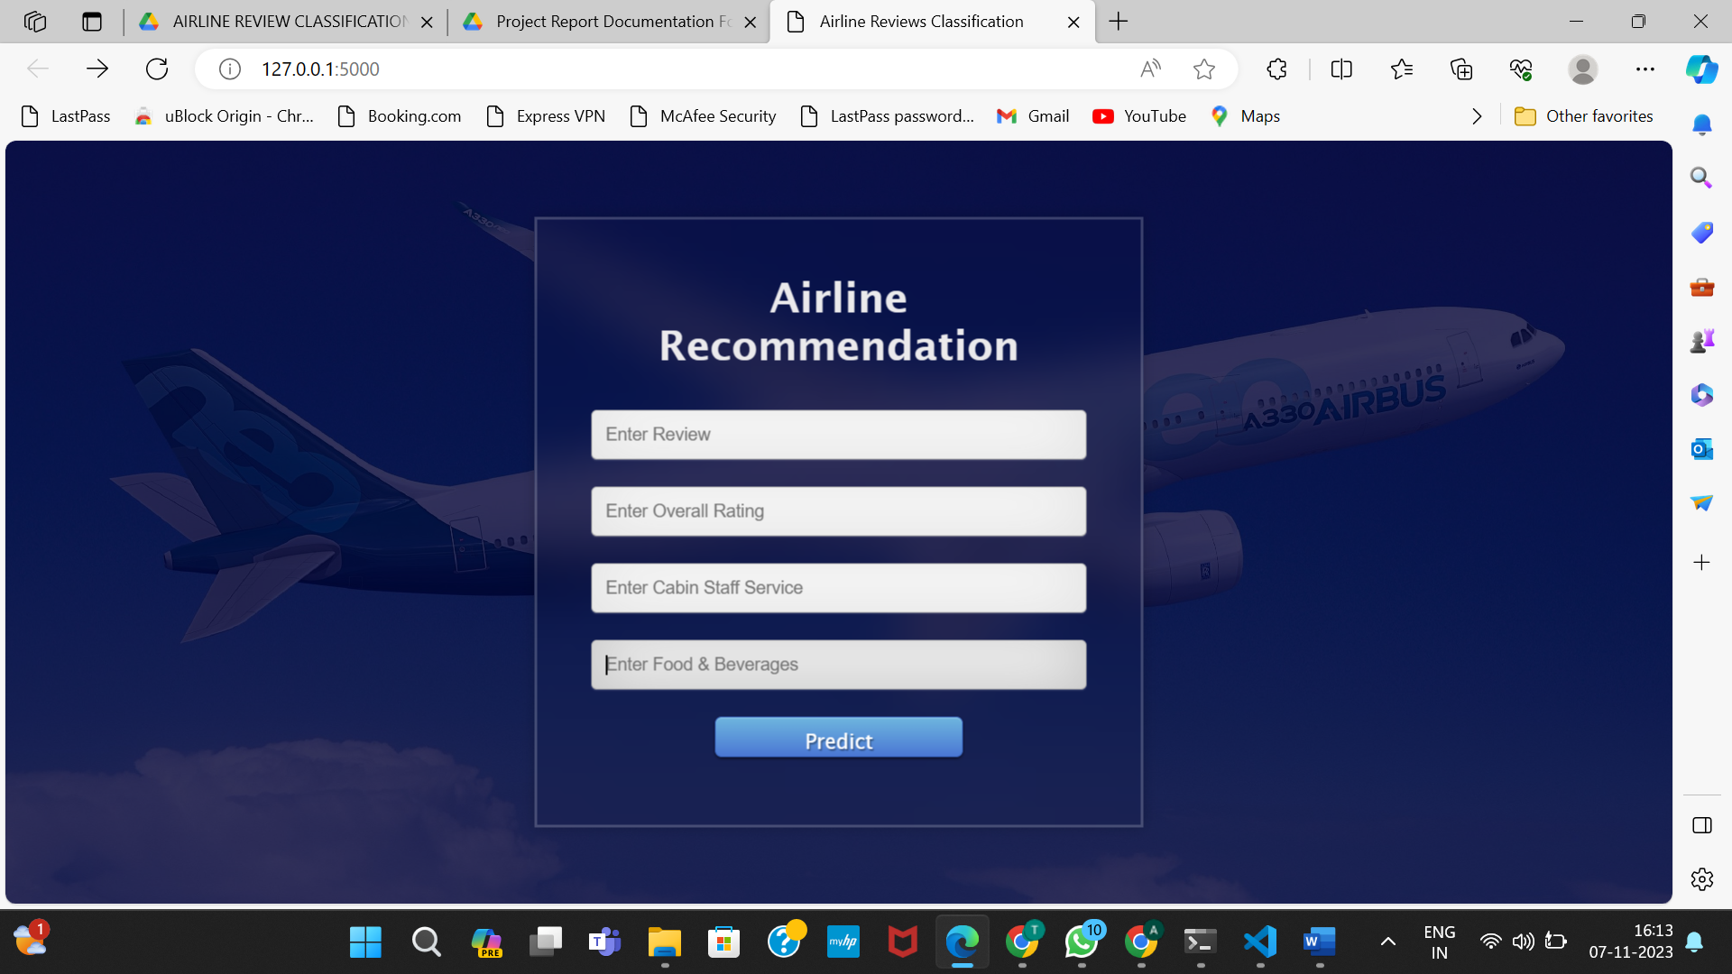

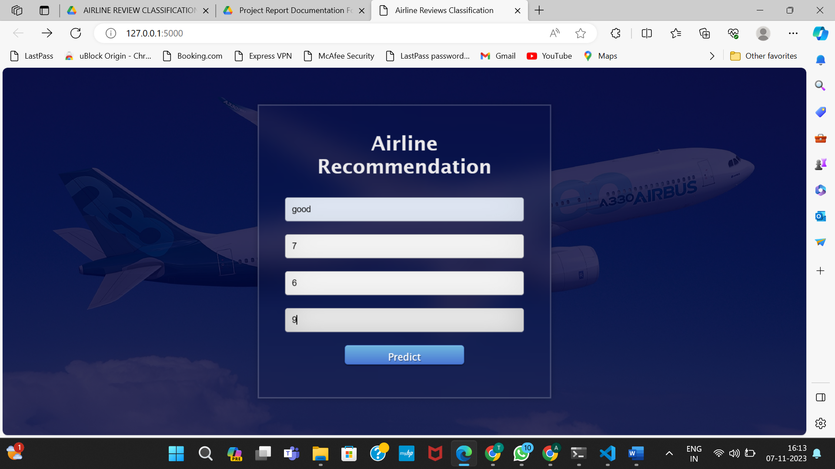

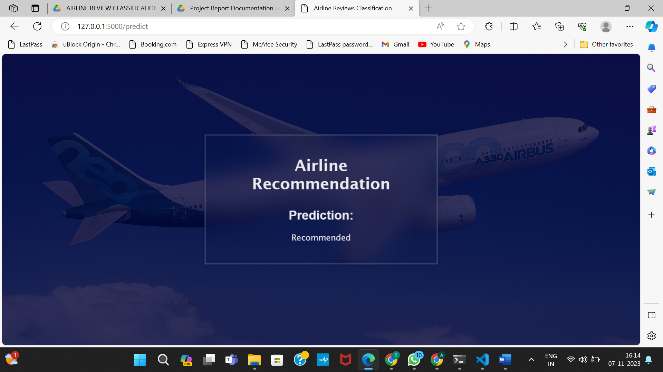

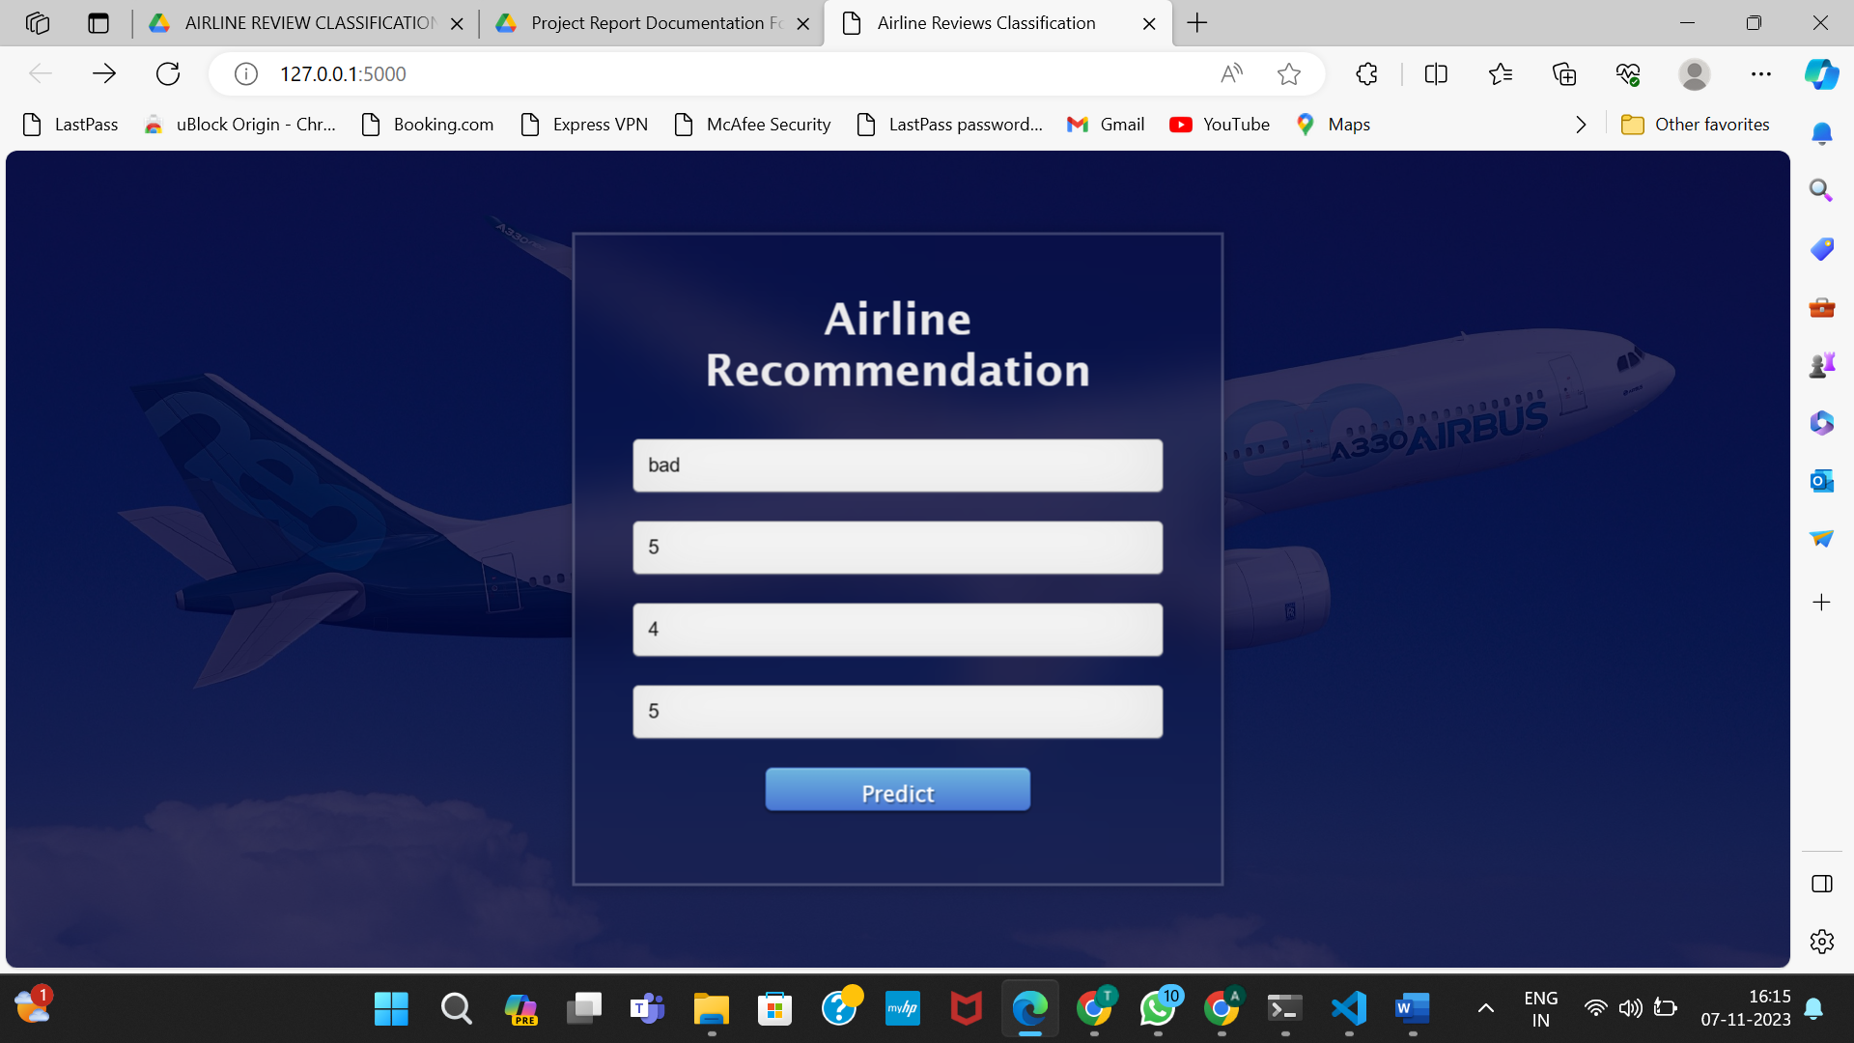

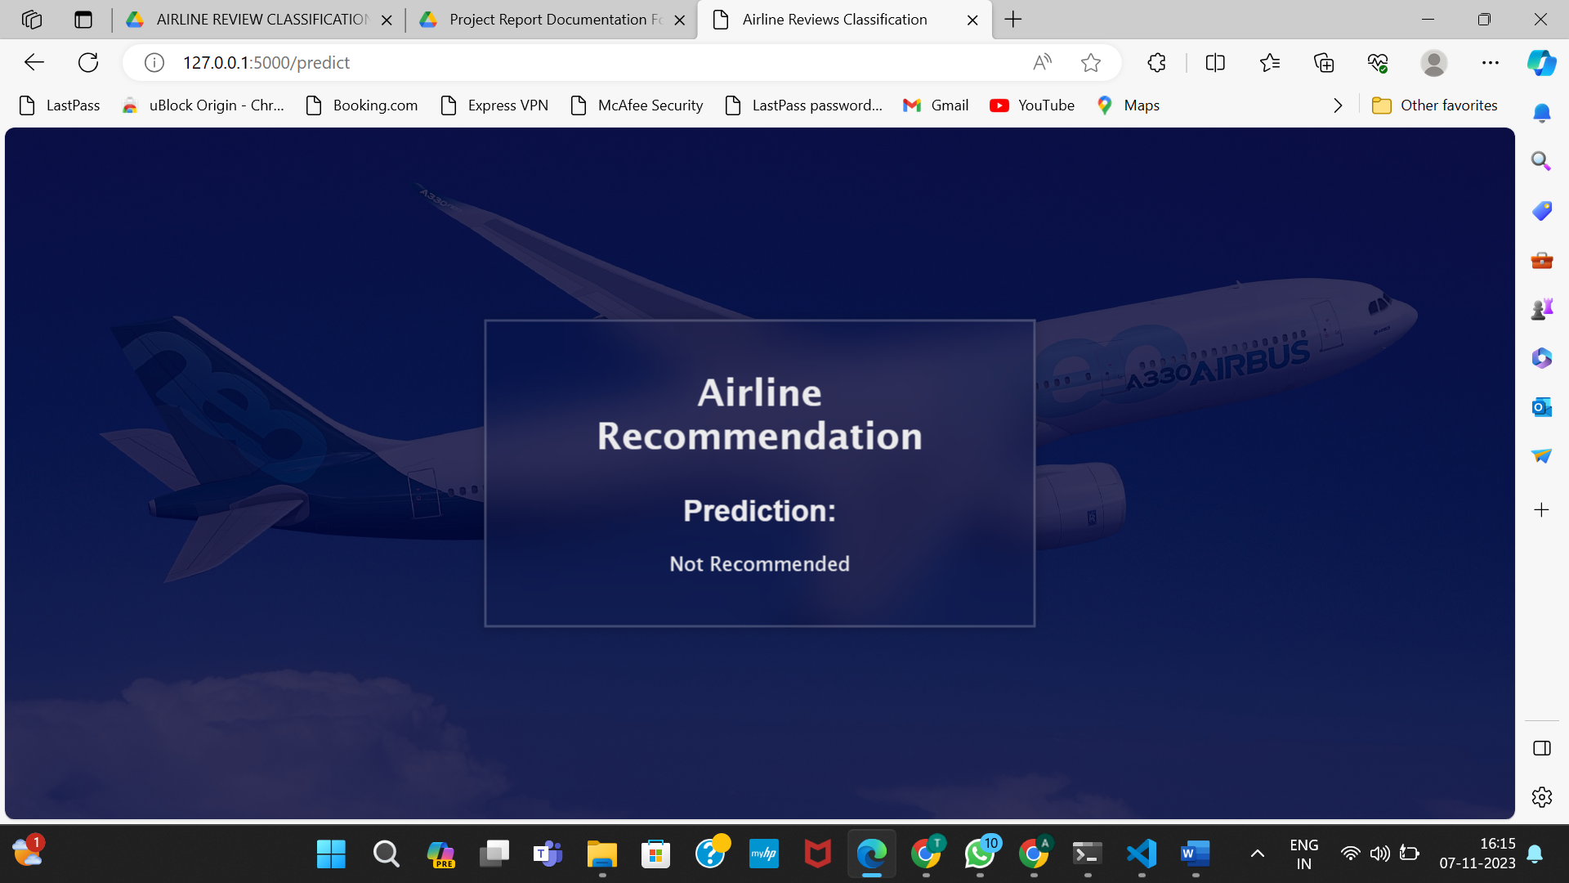

**10)**

**ADVANTAGES :**

The following are some of the best advantages of developing a machine learning model for airline review classification:

* Improved customer satisfaction: By understanding the sentiment of airline reviews, airlines can identify areas where they need to improve their services. This can lead to improved customer satisfaction and loyalty.
* Reduced costs: By automating the process of airline review classification, airlines can reduce the costs associated with manual review.
* Increased efficiency: Machine learning models can classify airline reviews much faster than human analysts. This can help airlines to identify and respond to customer feedback more quickly.
* Improved decision-making: Machine learning models can provide airlines with insights into the customer experience that would be difficult to obtain through traditional methods. This information can be used to make better decisions about how to allocate resources and improve services.

Here are some specific examples of how airlines can use machine learning to classify airline reviews:

* Identifying common customer complaints: Airlines can use machine learning to identify the most common customer complaints. This information can then be used to improve services or develop new products and services.
* Tracking customer sentiment over time: Airlines can use machine learning to track customer sentiment over time. This can help them to identify trends and changes in customer satisfaction.
* Identifying customer segments: Airlines can use machine learning to identify different customer segments. This information can then be used to target marketing campaigns and improve customer service.
* Personalizing customer experiences: Airlines can use machine learning to personalize the customer experience. For example, they can use machine learning to recommend flights or products to customers based on their past travel history and preferences.

Overall, machine learning can be a valuable tool for airlines to improve their services and customer satisfaction. By developing and using machine learning models to classify airline reviews, airlines can gain valuable insights into the customer experience and make better decisions about how to improve their business.

**DISADVANTAGES :**

* Data bias: Machine learning models are trained on data, and if the data is biased, the model will be biased as well. This can lead to inaccurate classifications of airline reviews.
* Model complexity: Machine learning models can become complex and difficult to understand. This can make it difficult to troubleshoot and maintain the model.
* Model maintenance: Machine learning models need to be regularly maintained and updated with new data. This can be a time-consuming and expensive process.
* Model explainability: It can be difficult to explain how a machine learning model makes its decisions. This can make it difficult to trust the model and to identify and correct errors.

**11) CONCLUSION :**

In conclusion, developing a machine learning model for airline review classification has the potential to provide airlines with a number of benefits, including improved customer satisfaction, reduced costs, increased efficiency, and improved decision-making. However, it is important to be aware of the potential disadvantages, such as data bias, model complexity, model maintenance, and model explainability.

Overall, we believe that the advantages of developing a machine learning model for airline review classification outweigh the disadvantages. However, it is important to carefully consider the needs of your airline and to develop a plan to mitigate the potential disadvantages before proceeding with the project.

we have did our project in the following way to ensure we get highly accurate results

* Use a high-quality dataset: The quality of your training data will have a significant impact on the performance of your model. Make sure to use a dataset that is representative of your customer base and that includes a variety of sentiment types.
* Choose the right machine learning algorithm: There are many different machine learning algorithms that can be used for airline review classification. Carefully consider the needs of your airline and the characteristics of your dataset when choosing an algorithm.
* Monitor the model's performance: It is important to monitor the performance of your model over time and to make adjustments as needed. This will help to ensure that the model is still accurate and reliable.
* Regularly update the model with new data: The airline industry is constantly changing, so it is important to regularly update your model with new data. This will help to ensure that the model is able to accurately classify reviews of new products and services.

**12) FUTURESCOPE :**

The future scope of machine learning models for airline review classification is very promising. As machine learning algorithms continue to improve and become more powerful, we can expect to see even more accurate and reliable models in the future.

In addition, as the volume of airline reviews continues to grow, machine learning models will become even more valuable to airlines. Machine learning models can help airlines to quickly and efficiently process large volumes of reviews and to identify the most important trends and insights.

Here are some specific ways in which machine learning models for airline review classification can be used in the future:

* Predicting customer satisfaction: Machine learning models can be used to predict customer satisfaction based on airline reviews. This information can be used to identify areas where airlines need to improve their services.
* Identifying customer segments: Machine learning models can be used to identify different customer segments based on their reviews. This information can be used to target marketing campaigns and improve customer service.
* Personalizing the customer experience: Machine learning models can be used to personalize the customer experience based on their reviews. For example, airlines can use machine learning to recommend flights or products to customers based on their past travel history and preferences.
* Automating customer service tasks: Machine learning models can be used to automate customer service tasks, such as responding to customer inquiries and resolving complaints. This can free up customer service agents to focus on more complex tasks.

Overall, the future of machine learning for airline review classification is very bright. As machine learning algorithms continue to improve and the volume of airline reviews continues to grow, we can expect to see machine learning models play an increasingly important role in the airline industry.

**13) Appendix:**

**SOURCE CODE :**

**Importing the Libraries :**

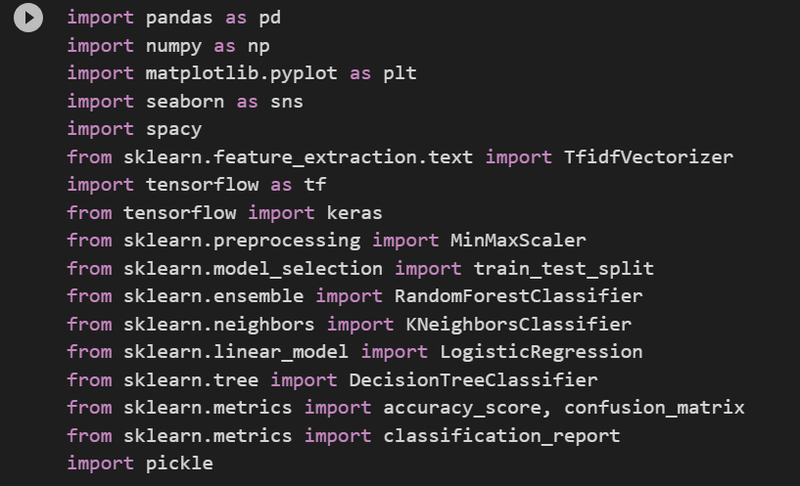

**Read the Dataset :**

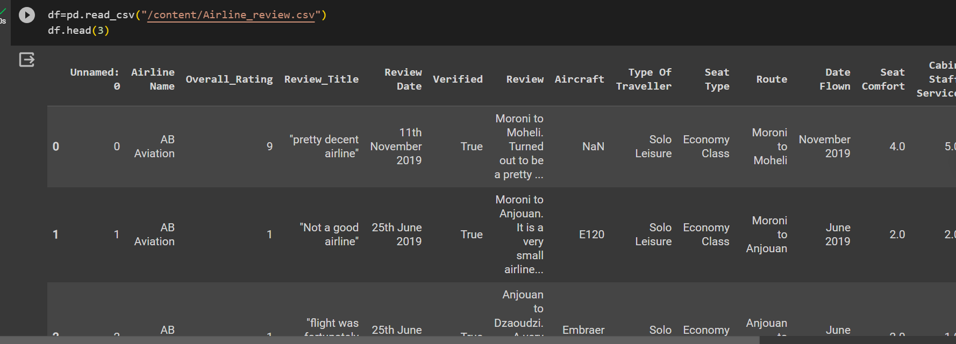

**Data Preparation**

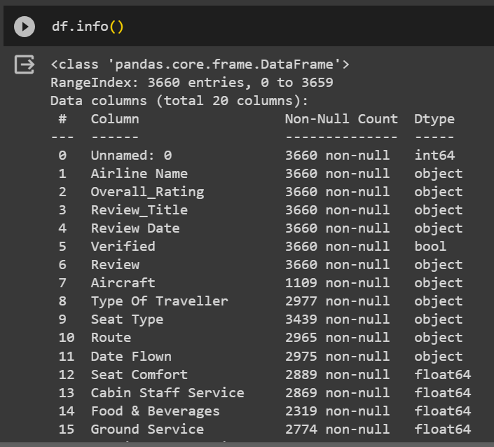



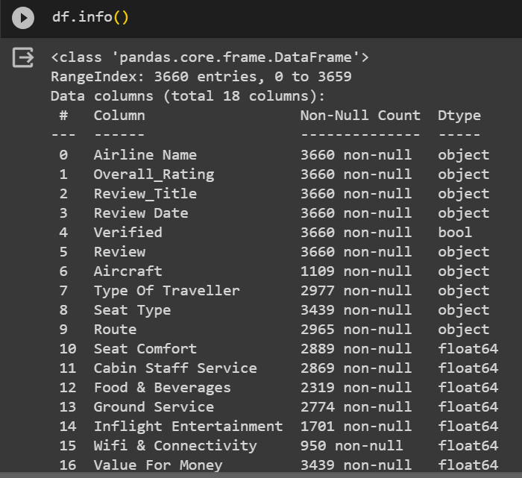

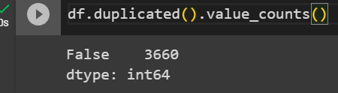

**Categorical columns:**

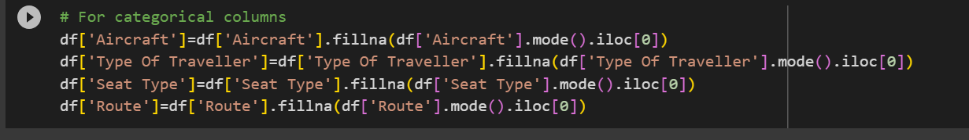

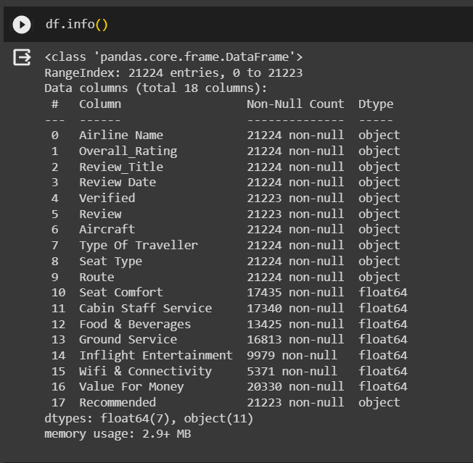

**Numerical Columns:**



**Data Preprocessing:**

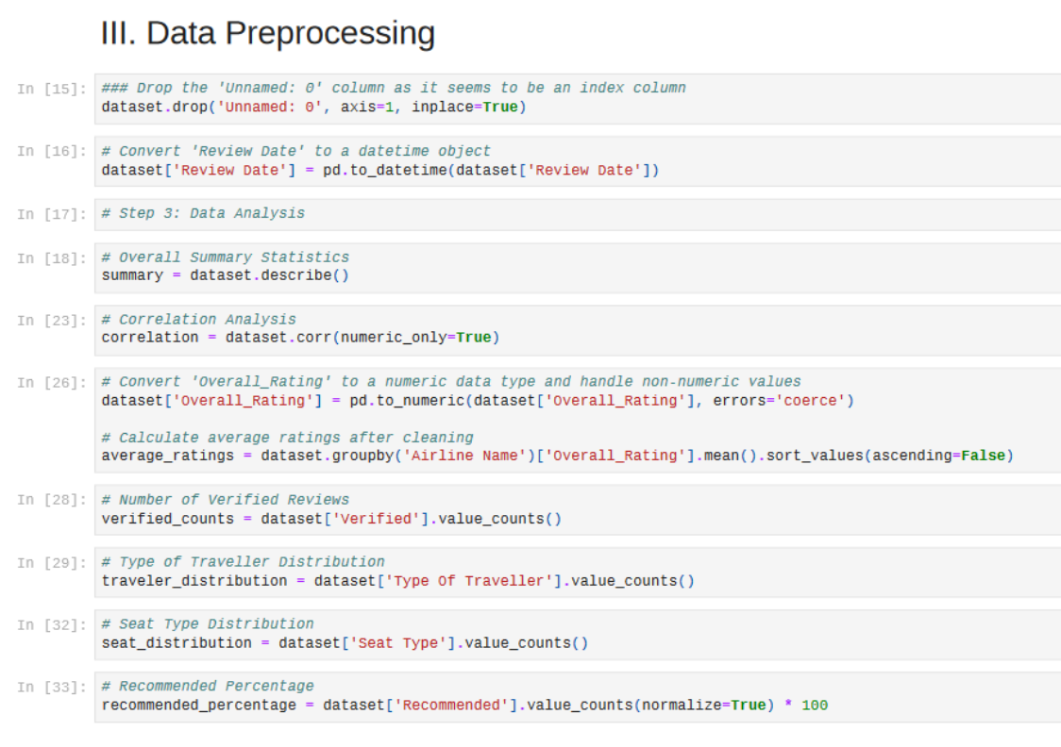

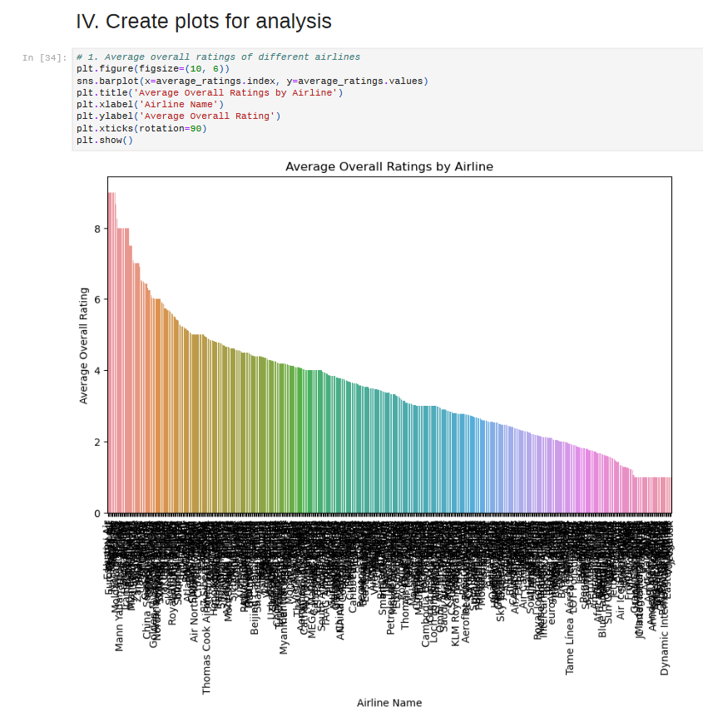

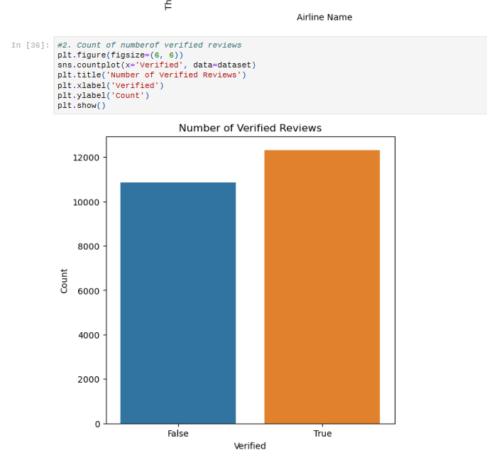

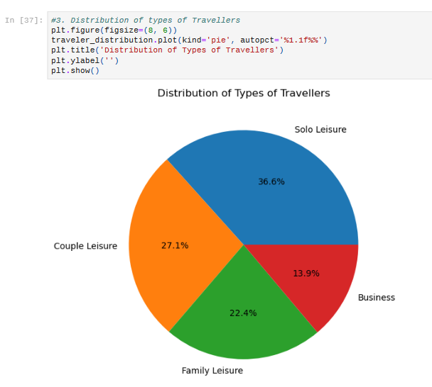

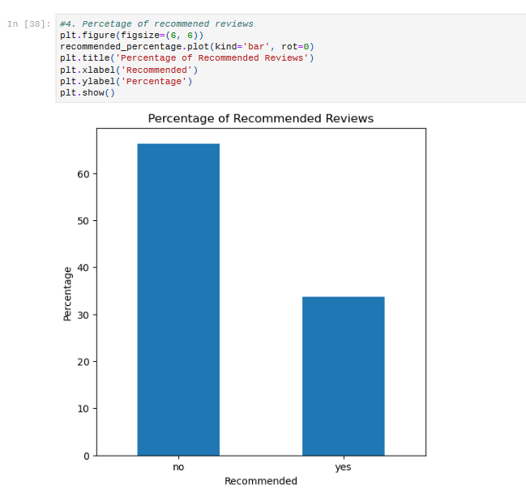

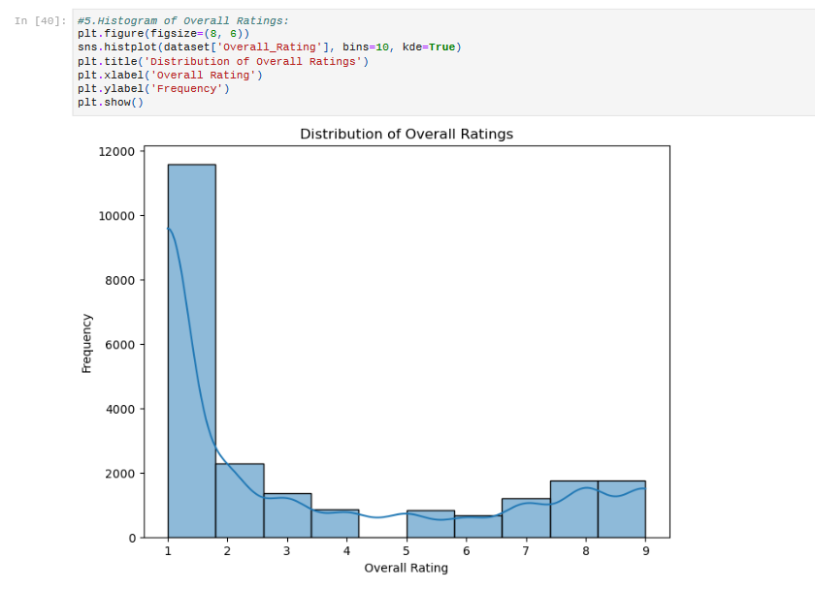

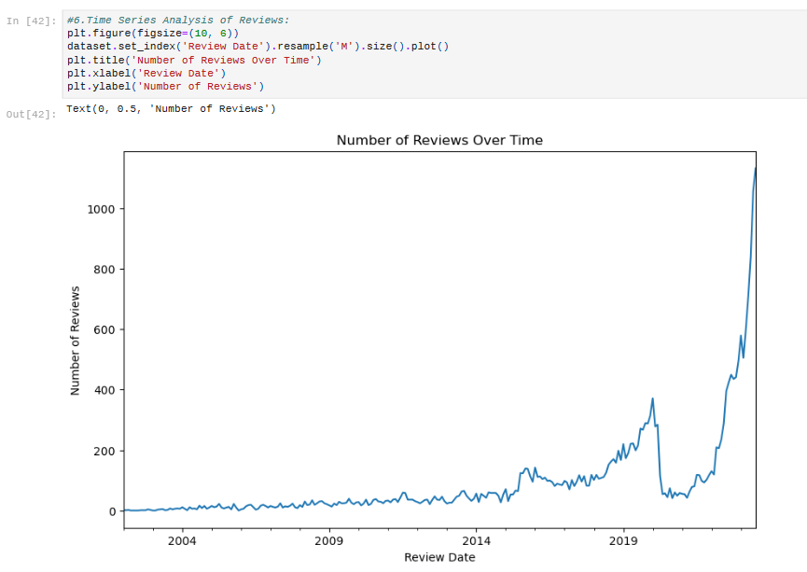

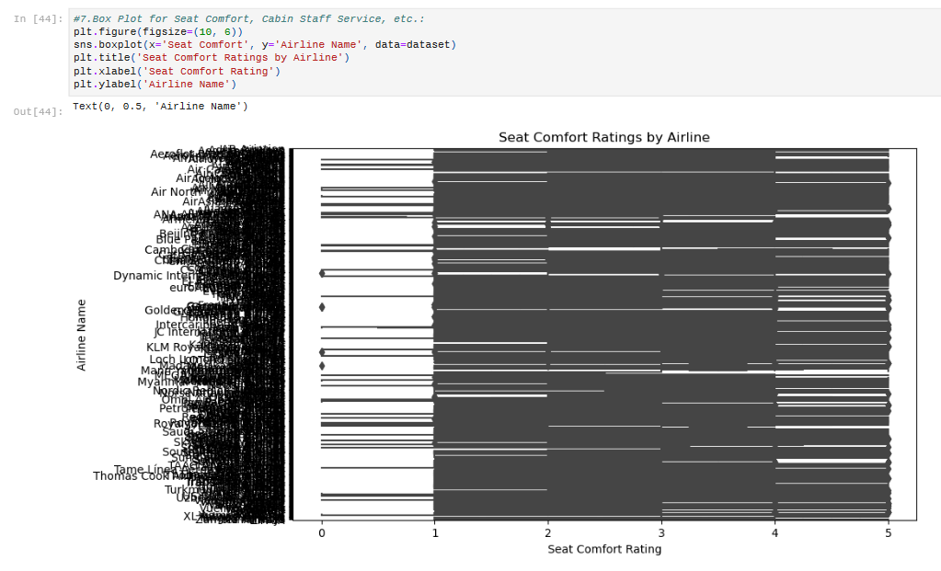

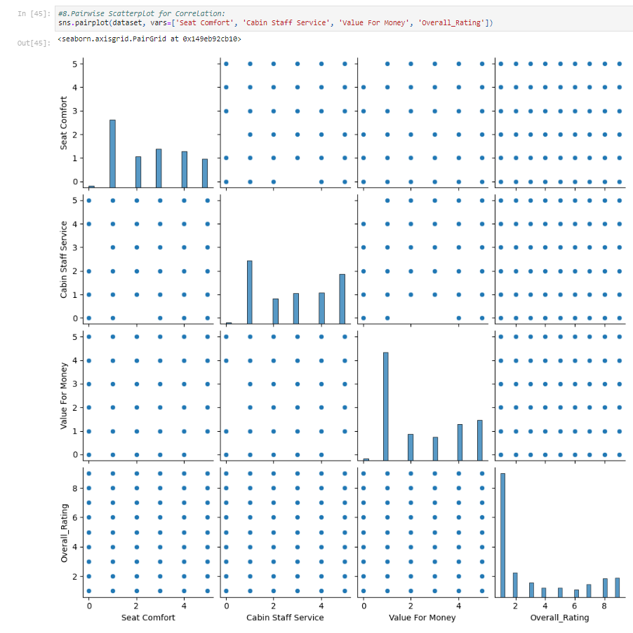

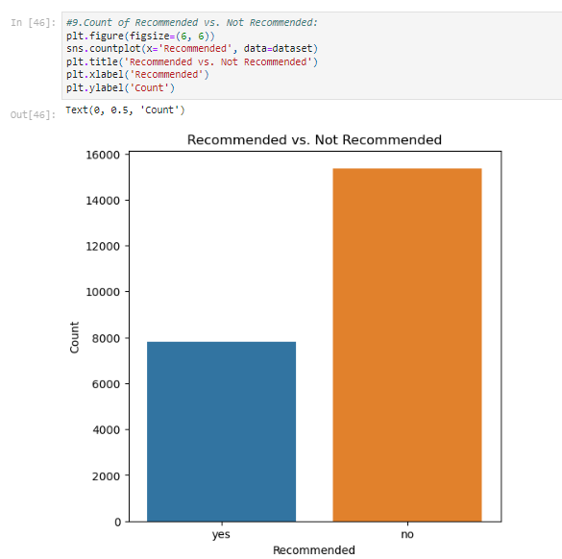

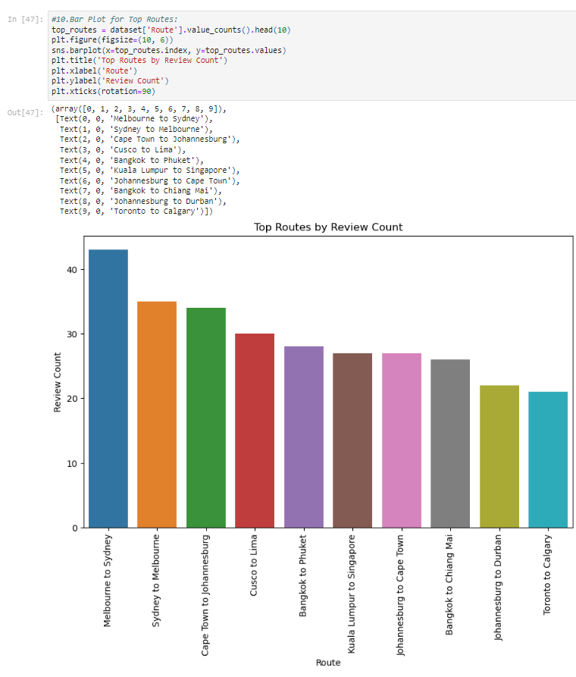

**Data Visualization:**

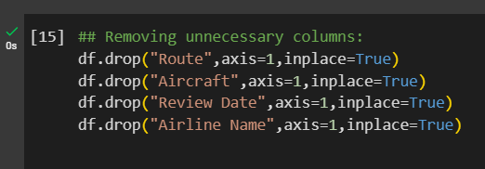

**Encoding:**

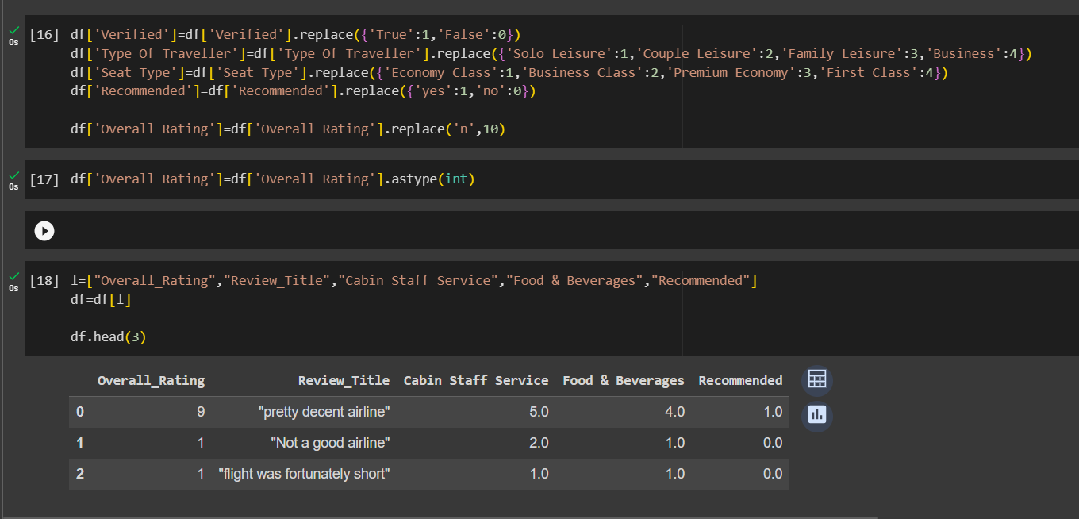

**Preprocessing using Spacy:**

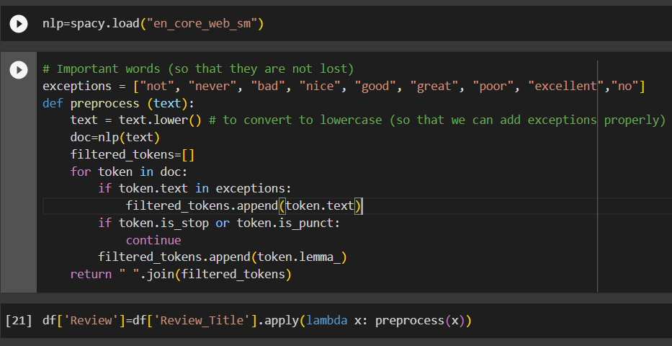

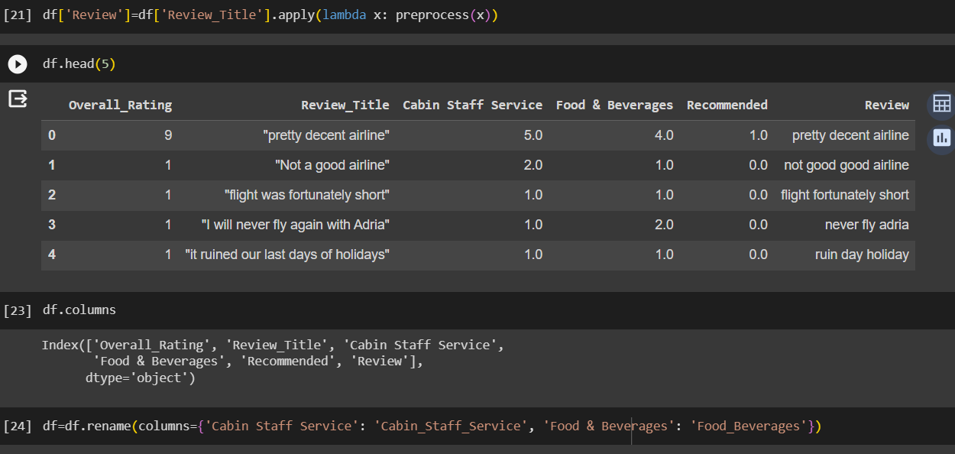

**Text Vectorization:**

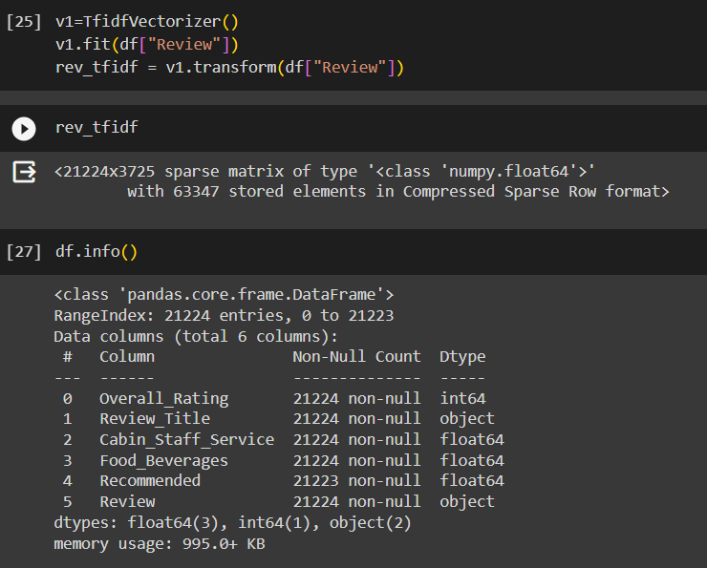

**Data Splitting:**

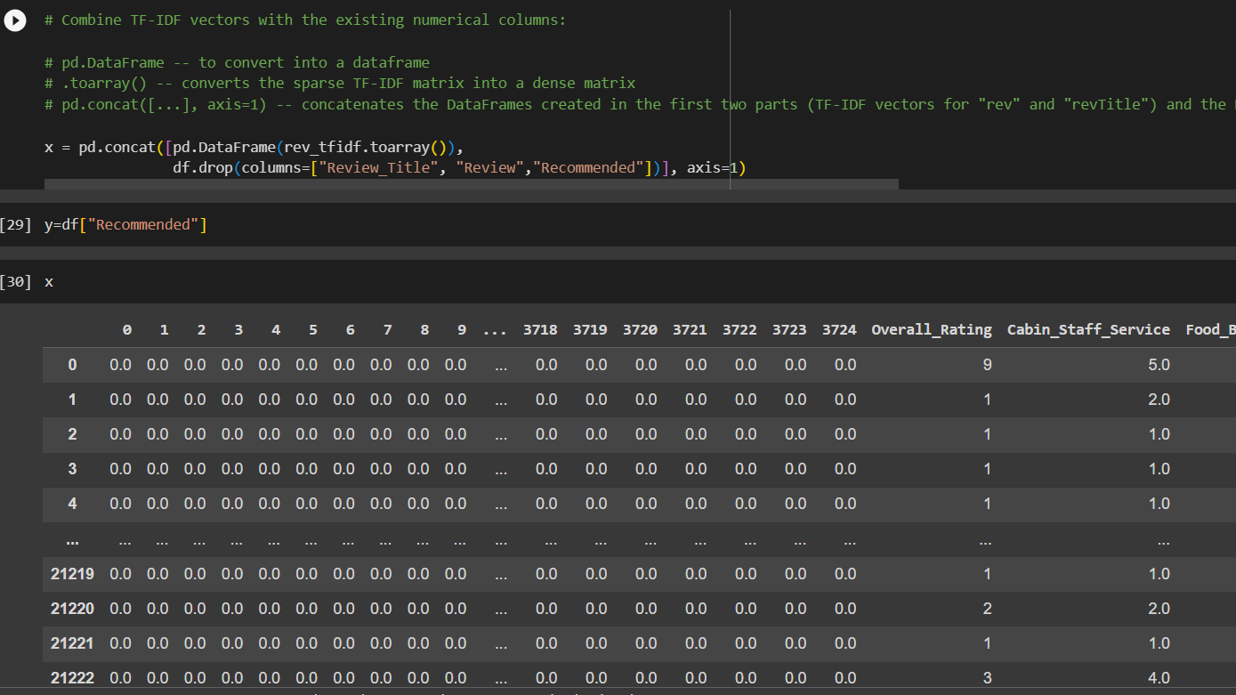

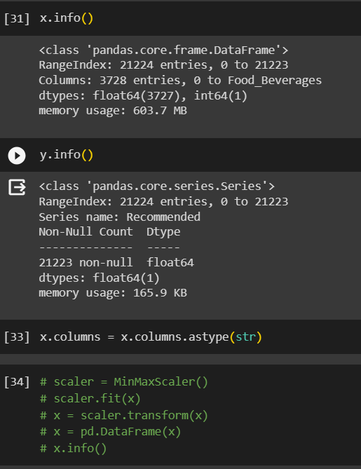

**Training,Testing & Splitting:**

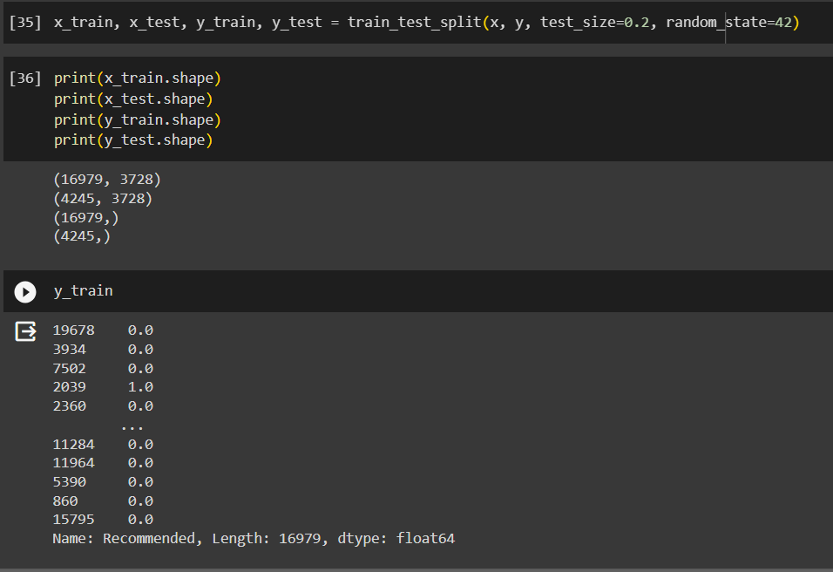

**Model Training**

1. **Neural Networks**

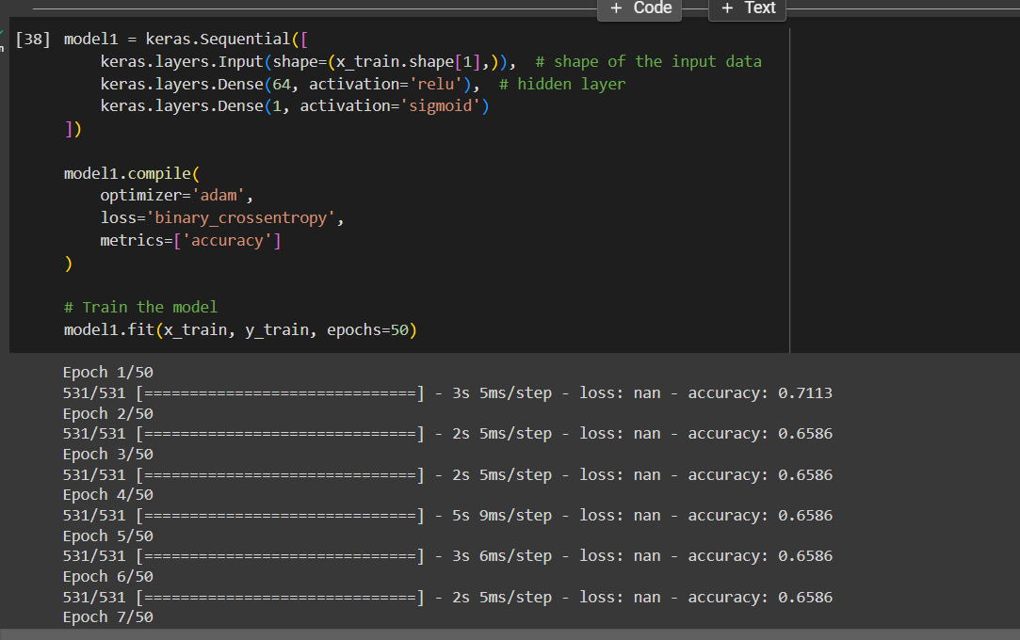

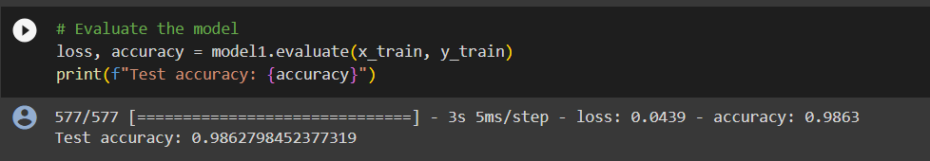

1. **Random Forest Classifier**

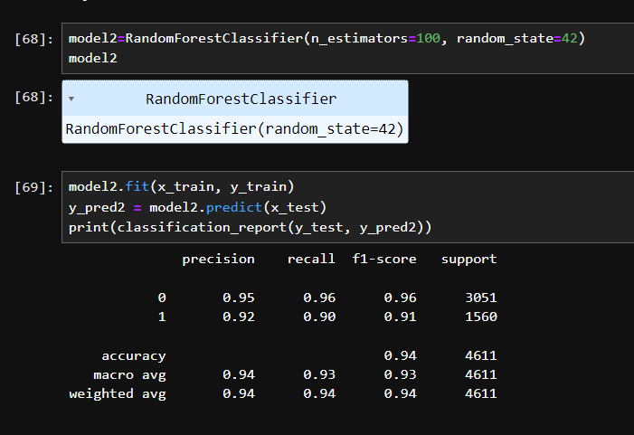

1. **KNeighborsClassifier**

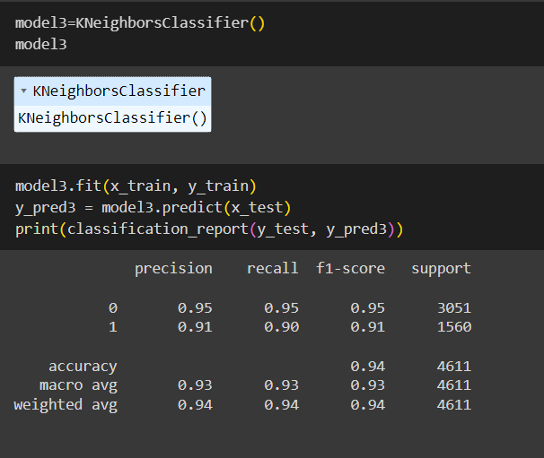

1. **Decision Tree Classifier:**

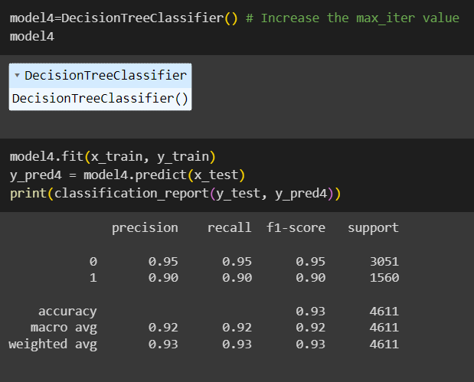

1. **Logistic Regression:**

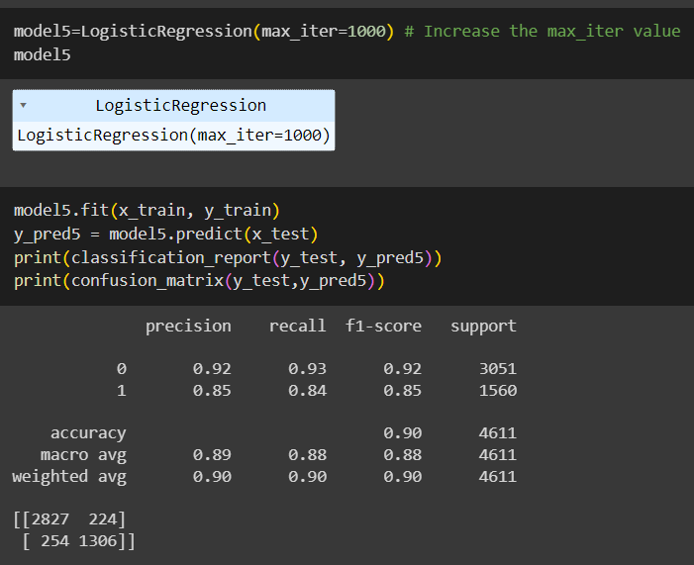

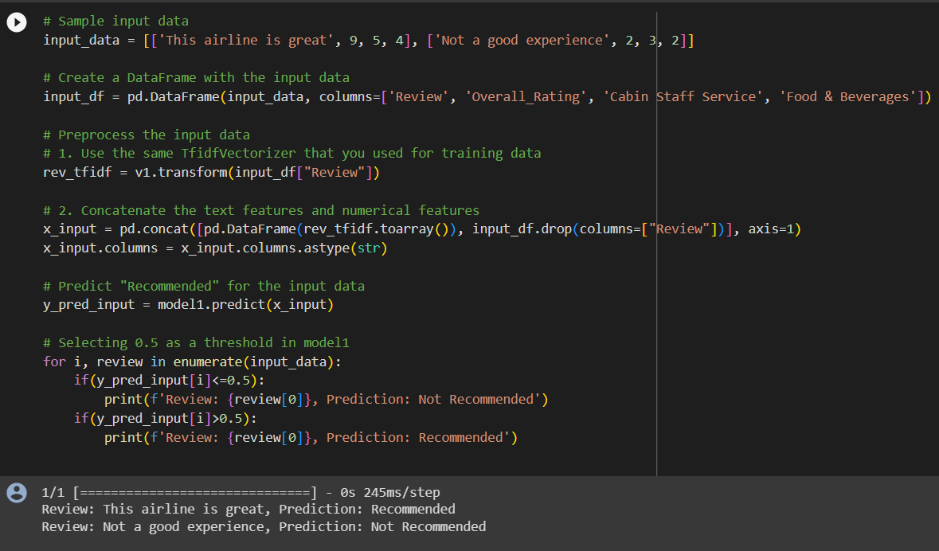

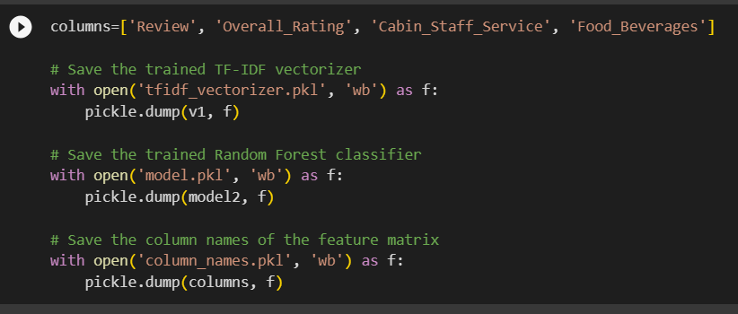

**Flask File:**

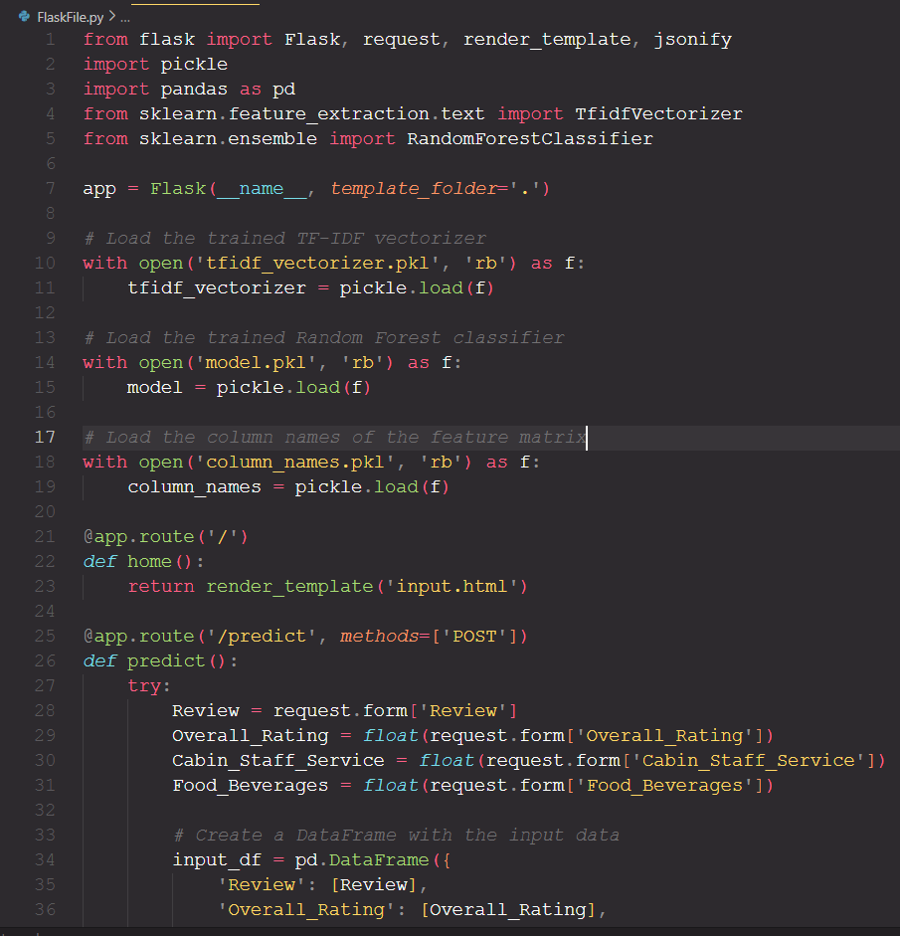

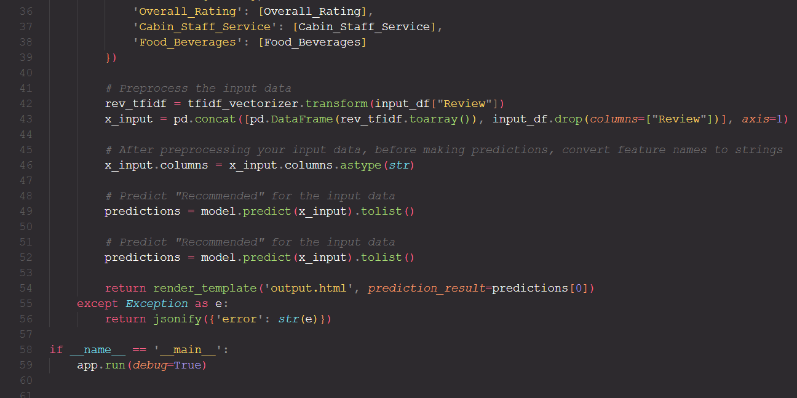

**HTML Files:**

